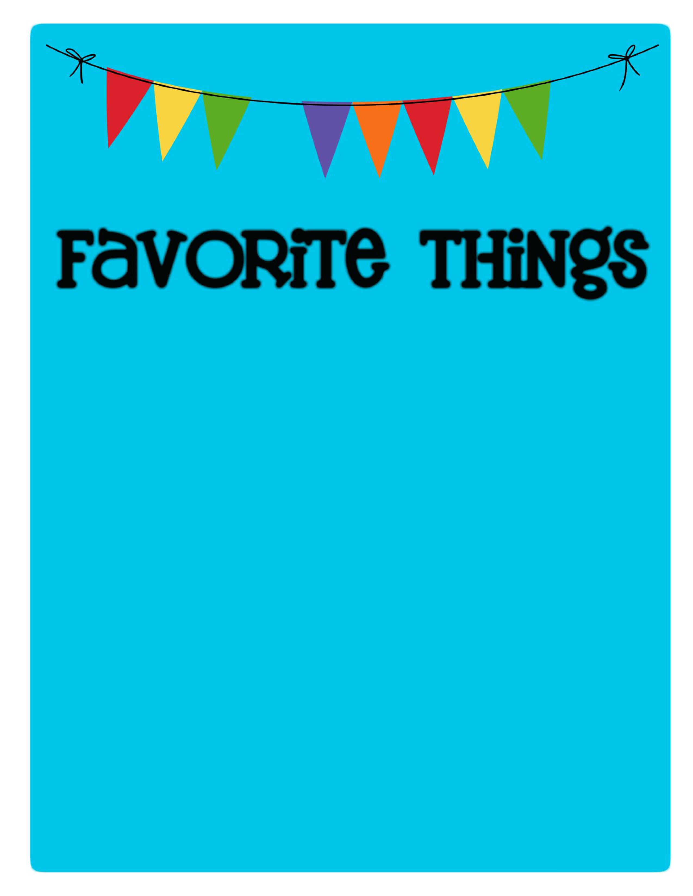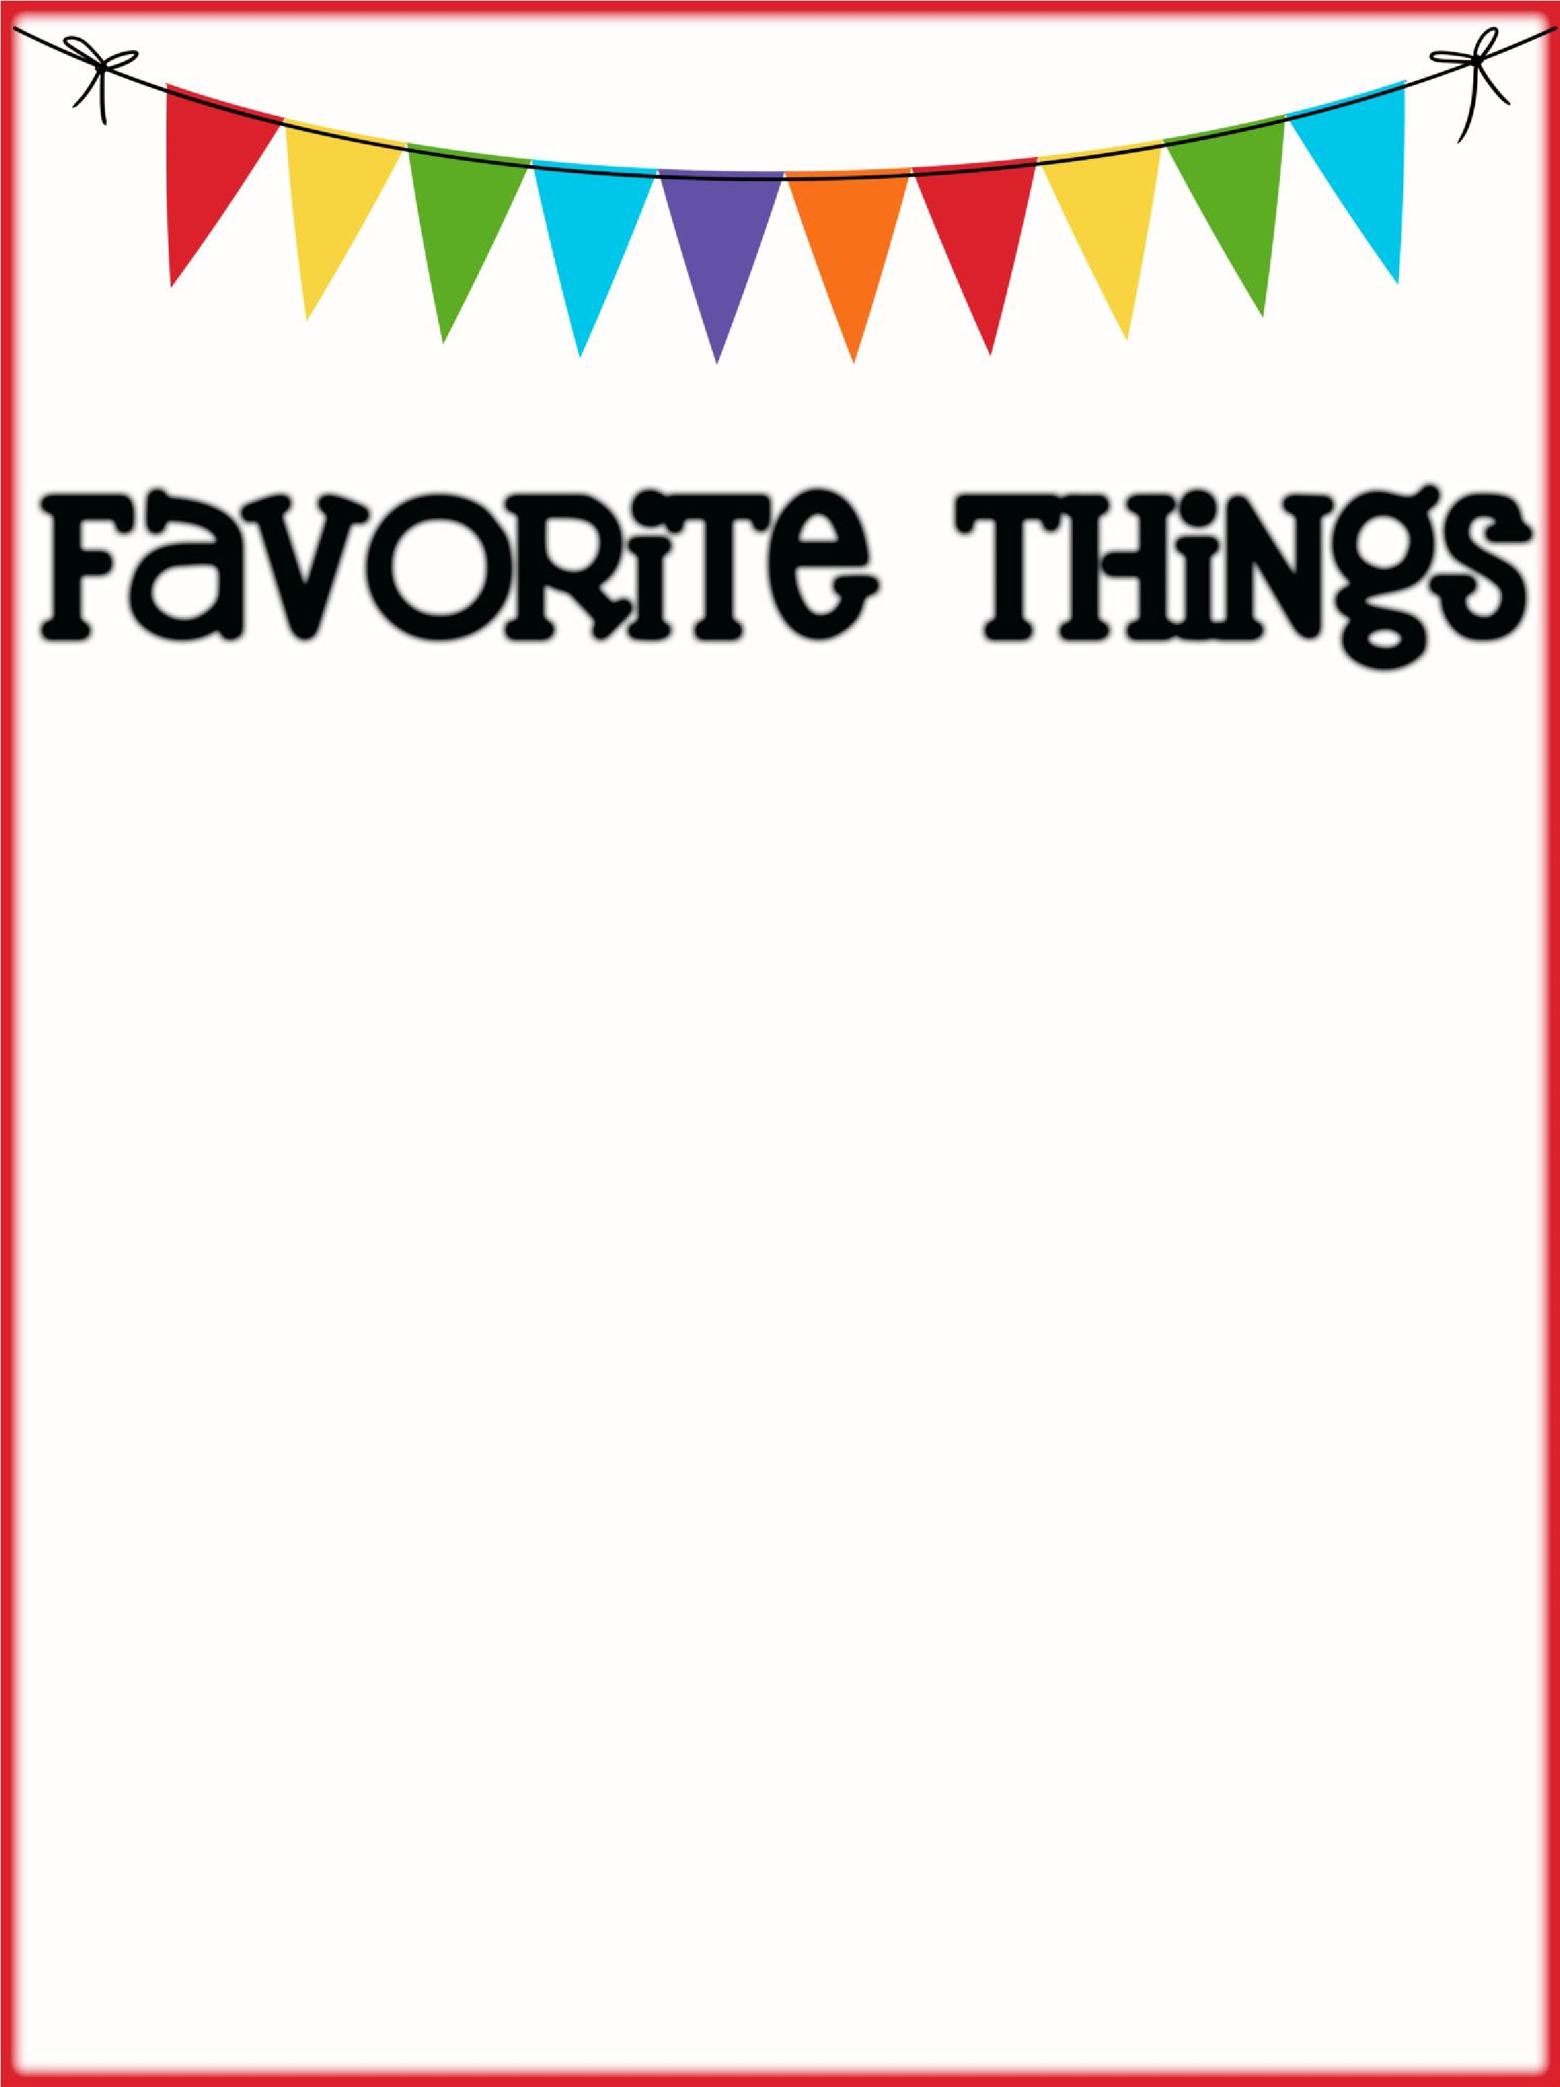

Name: Kim Lind _________________________

Birthday: _April 12th_________________________________________

Favorites

Places to Eat: ___Texas Roadhouse, Olive Garden, Chipotle _______________________________________________

Places to Shop:

_TJ Maxx, Amazon, Target

Favorite Gift Cards:_ TJ Maxx, Target, Amazon, Harkins

Drinks :

Starbucks

:

___Regular coffee with cream ________________________________

Sonic

:

__Diet Coke ____________________________________

Other

:

___Diet Coke

Scents (lotion, Scentsy, etc.): Foaming Wash Bath & Body Works, Beach

Candy/Snacks: __Veggie Chips, Popcorn ________________________________

Cookies/Cake: Chocolate Chip, sugar White Cake

Flowers

:

____

any

Hobbies/Collectibles: ___Ohio State, season items from Home Goods

Other Wish List Items: _Teacher pay teachers, Amazon